12/13/2024

**HANAN MAJEED**

**519166**

FUNDAMENTAL OF COMPUTER PROGRAMMING

LAB_13

**Task A:**

Write a recursive function to calculate the sum of the digits of a positive integer entered by the user. The function will break the number into its individual digits by repeatedly extracting the last digit and dividing the number by 10. The recursion will continue until the number becomes 0, which serves as the base case.

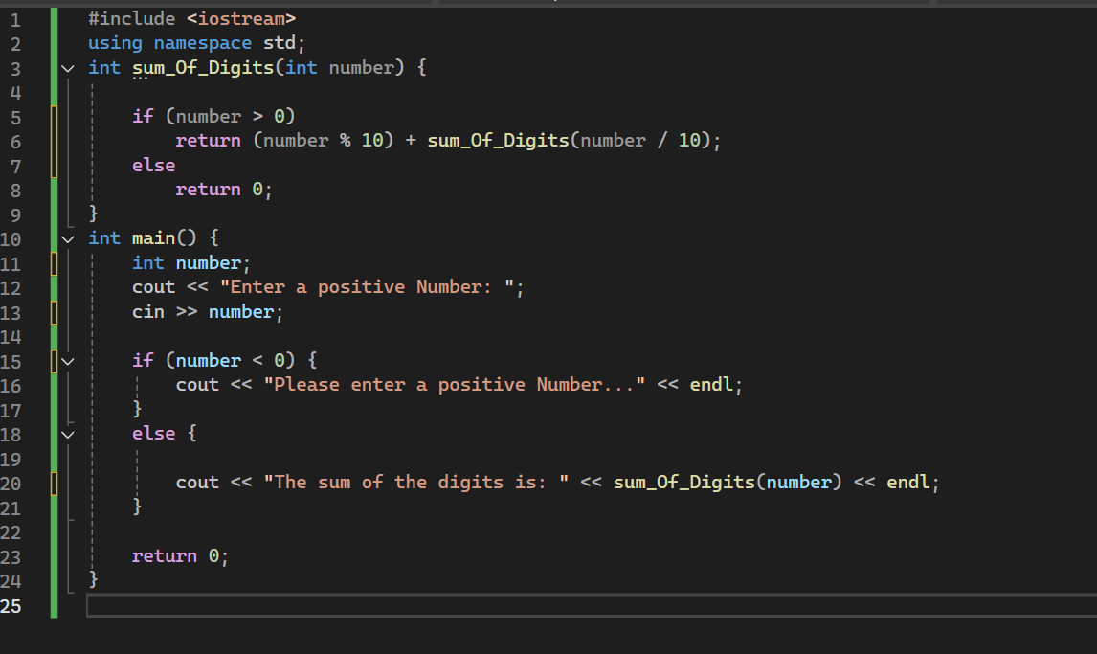**input:**

**output:**

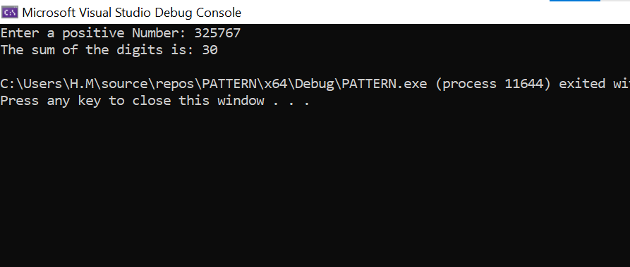

**Task B:**

Write a program that gets 10 numbers from the users in an array. Write the following recursive functions to perform relevant operations on the array.

* Sort the array using recursive bubble sort. Swapping in the bubble sort should also be done recursively
* Display the array using a tail recursive function to display in ascending order
* Display the array in a descending order using a head recursive function

**Input:**

**Output:**

**Task C:**

Write a program to analyze a user-input string and count the number of vowels, consonants, and digits using recursion. For each character, the function will determine whether it is a vowel, consonant, or digit. Non-alphanumeric characters will be ignored.

**Input:**

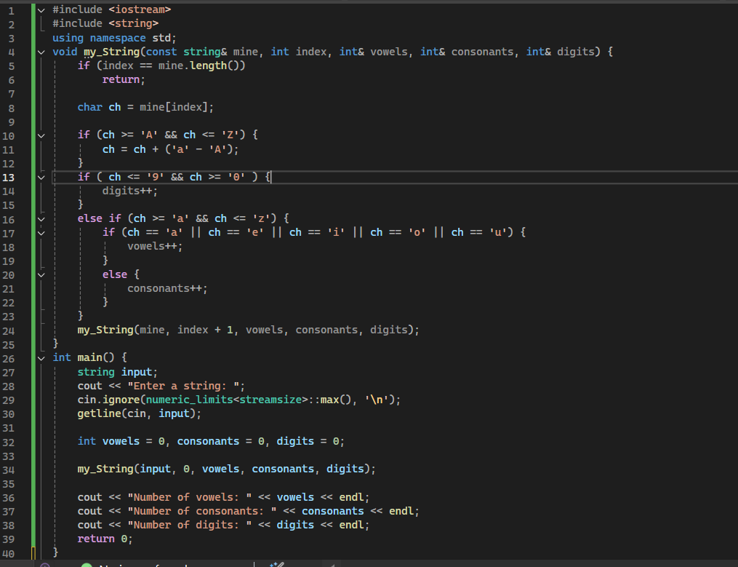

**Output:**

